**Class and Quiz Snapshots:**

**Programming in c++( 9 to 1.30)**

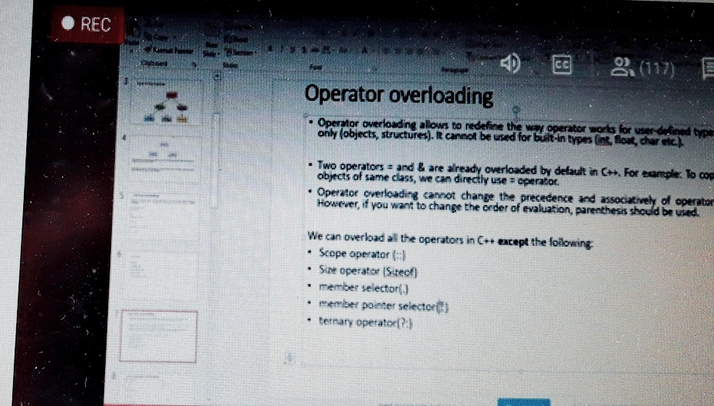

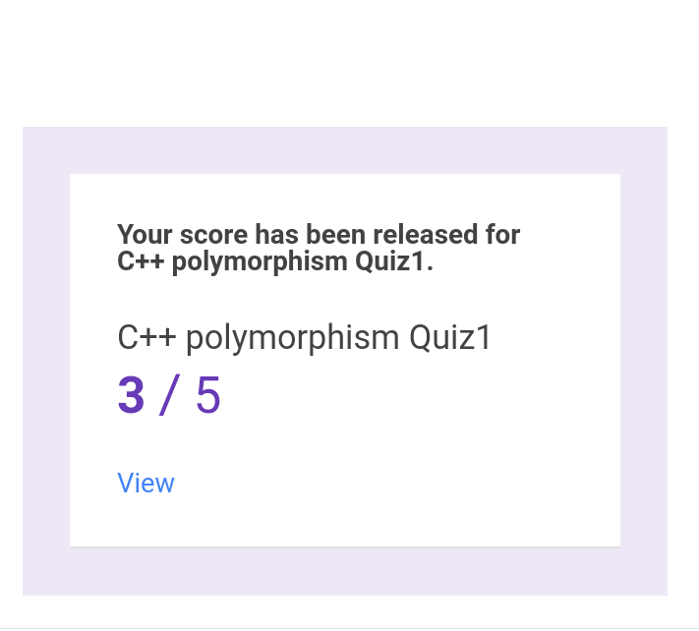

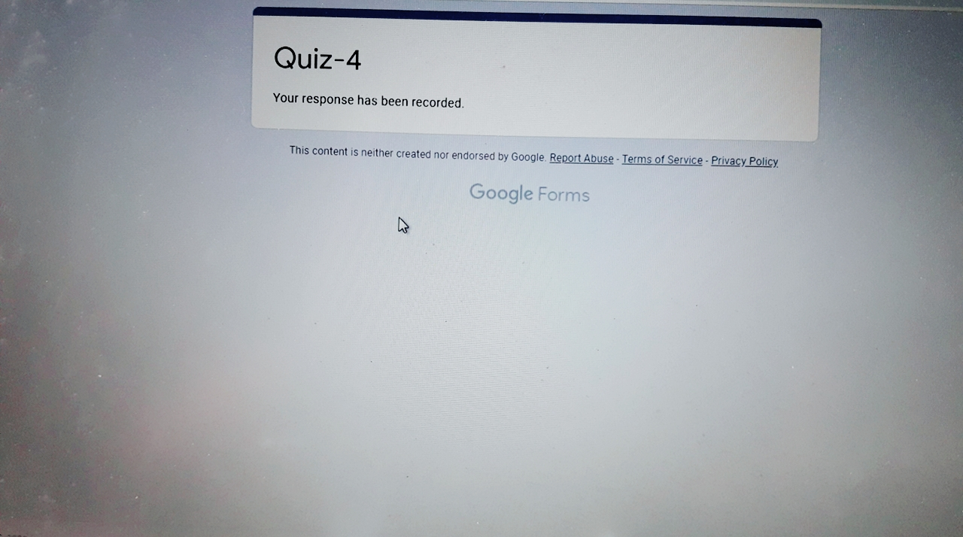

**Programming in c++ (from 11.30 to 1.10)**

